**Bahria University, Lahore Campus**

Department of Computer Science

Lab Journal 02

**(Spring 2023)**

|  |  |  |
| --- | --- | --- |
| Course: | **Data Structures and Algorithm - Lab** | Date: _______________ |
| Course Code: | CSL-221 | Max Marks: 10 |
| Faculty’s Name: | Fatima Zulfiqar |  |

Name: AFFAN AHMAD_ Enroll No: _03-134221-003_ Class: _BS(cs)_____________

Objective(s):

Upon completion of this lab session, learners will be able to:

* Define structures
* Define & Implement an Array of Structures
* Pass Structure to Function
* Implement bubble sort and selection sort algorithm.

## Lab Tasks:

**Task 1**

Write a program to create structure named employee. Take information of 10 employees from user as input (EmpID, EmpName, EmpAge, EmpSalary) Display the output. The program should be implemented using a function.

#include <iostream>

using namespace std;

int s = 2;

struct employee

{

int empid, empage, empsalary;

char empname[10];

};

void display(employee e1[],int s )

{

for (int i = 0; i < s; i++)

{

cout << " the " << i + 1 << "employee id is:" << e1[i].empid << endl;

cout << " the " << i + 1 << "employee age is:" << e1[i].empage << endl;

cout << " the " << i + 1 << "employee salary is:" << e1[i].empsalary << endl;

cout << " the " << i + 1 << "employee name is:" << e1[i].empname << endl;

}

}

int main()

{

int s = 2;

employee e1[2];

for (int i = 0; i < 2; i++)

{

cout << "enter the " << i + 1 << " id:";

cin >> e1[i].empid;

cout << "enter the " << i + 1 << " age:";

cin >> e1[i].empage;

cout << "enter the " << i + 1 << " salary:";

cin >> e1[i].empsalary;

cout << "enter the " << i + 1 << " name:";

cin >> e1[i].empname;

cout << endl;

}

display(e1, 2);

system("pause");

return 0;

}

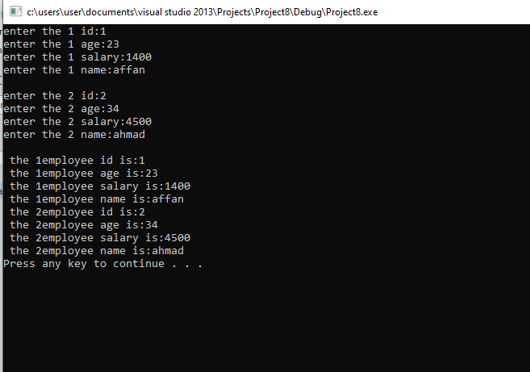

**Task 2**

Enter the marks of 10 students in Computer Programming, ICT and Object-Oriented Programming (each out of 100) using a structure named ***Marks*** having elements roll no., name, cp_marks, oop_marks, and dsa_marks, and then display the percentage of each student.

#include <iostream>

using namespace std;

int s = 2;

struct marks

{

int rollno , oop_marks, dsa_marks,cp_marks,per,a;

char name[10];

};

void display(marks e1[],int s )

{

for (int i = 0; i < s; i++)

{

cout << " the " << i + 1 << " student name is:" << e1[i].name << endl;

cout << " the " << i + 1 << "student rollno is:" << e1[i].rollno << endl;

cout << " the " << i + 1 << "student oop marks is:" << e1[i].oop_marks << endl;

cout << " the " << i + 1 << "student dsa marks is:" << e1[i].dsa_marks << endl;

cout << " the " << i + 1 << "student cp is:" << e1[i].cp_marks << endl;

e1[i].a = e1[i].oop_marks + e1[i].cp_marks + e1[i].dsa_marks/300;

e1[i].per = e1[i].a *100 /100;

cout << "the " << i + 1 << "student percentage is :" << e1[i].per << endl;

}

}

void selectionsorting(employee e1[], int s)

{

int temp,min;

cout << "sorted emoployee salary is :" << endl;

for (int i = 0; i < s; i++)

{

min = i;

for (int j = i+1; j < s; j++)

{

if (e1[j].empsalary < e1[i].empsalary)

{

min = j;

}

}

temp = e1[min].empsalary;

e1[min].empsalary = e1[i].empsalary;

e1[i].empsalary = temp;

cout << temp << " ";

}

}

int main()

{

int s = 2;

marks e1[2];

for (int i = 0; i < 2; i++)

{

cout << "enter the " << i + 1 << "student name:";

cin >> e1[i].name;

cout << "enter the " << i + 1 << "student rollno:";

cin >> e1[i].rollno;

cout << "enter the " << i + 1 << "student oop marks:";

cin >> e1[i].oop_marks;

cout << "enter the " << i + 1 << "student dsa marks:";

cin >> e1[i].dsa_marks;

cout << "enter the " << i + 1 << "student cp marks:";

cin >> e1[i].cp_marks;

cout << endl;

}

display(e1, 2);

system("pause");

return 0;

}  
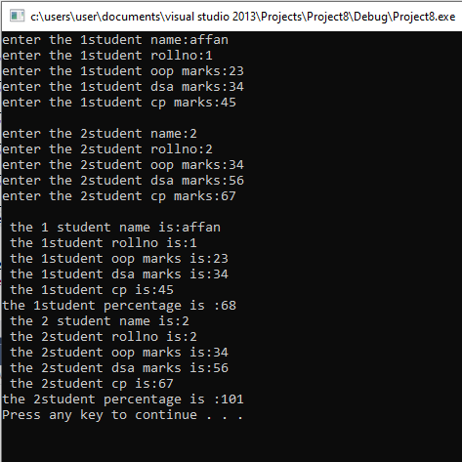

**Task 3**

Sort employee information from Task 1 according to the decreasing order the employee salary. Use bubble sort algorithm and display complete information before and after sorting.

#include <iostream>

using namespace std;

int s = 2,temp;

struct employee

{

int empid, empage, empsalary,temp;

char empname[10];

};

void display(employee e1[], int s)

{

for (int i = 0; i < s; i++)

{

//cout << " the " << i + 1 << "employee salary is:" << e1[i].empsalary << endl;

}

}

void bubblesorting(employee e1[], int s)

{

employee temp;

cout << "sorted emoployee salary is :" << endl;

for (int i = 0; i < s; i++)

{

for (int j = 0; j < s-1; j++)

{

if (e1[j].empsalary > e1[j + 1].empsalary)

{

temp = e1[i];

e1[i] = e1[i+1];

e1[i + 1] =temp ;

}

}

}

for (int i = 0; i < s; i++)

{

cout << e1[i].empsalary << " ";

cout << " the " << i + 1 << "employee id is:" << e1[i].empid << endl;

cout << " the " << i + 1 << "employee age is:" << e1[i].empage << endl;

cout << " the " << i + 1 << "employee name is:" << e1[i].empname << endl;

}

}

void selectionsorting(employee e1[], int s)

{

int temp,min;

cout << "sorted emoployee salary is :" << endl;

for (int i = 0; i < s; i++)

{

min = i;

for (int j = i+1; j < s; j++)

{

if (e1[j].empsalary < e1[i].empsalary)

{

min = j;

}

}

temp = e1[min].empsalary;

e1[min].empsalary = e1[i].empsalary;

e1[i].empsalary = temp;

cout << temp << " ";

}

}

int main()

{

int s = 2;

employee e1[2];

for (int i = 0; i < 2; i++)

{

cout << "enter the " << i + 1 << " id:";

cin >> e1[i].empid;

cout << "enter the " << i + 1 << " age:";

cin >> e1[i].empage;

cout << "enter the " << i + 1 << " salary:";

cin >> e1[i].empsalary;

cout << "enter the " << i + 1 << " name:";

cin >> e1[i].empname;

cout << endl;

}

//display(e1, 2);

bubblesorting(e1, 2);

system("pause");

return 0;

}

**Task 4**

Sort students information from Task 2 in such a way that the information of student who got least percentage should be displayed first. Use selection sort algorithm in this case. Also display complete information before and after sorting.

#include <iostream>

using namespace std;

int s = 2;

struct marks

{

int rollno, oop_marks, dsa_marks, cp_marks, per, a;

char name[10];

};

void display(marks e1[], int s)

{

for (int i = 0; i < s; i++)

{

e1[i].a = e1[i].oop_marks + e1[i].cp_marks + e1[i].dsa_marks / 300;

e1[i].per = e1[i].a * 100 / 300;

cout << "the " << i + 1 << "student percentage is :" << e1[i].per << endl;

}

}

void selectionsorting(marks e1[], int s)

{

marks temp;

int min;

cout << "sorted student marks is :" << endl;

for (int i = 0; i < s; i++)

{

min = i;

for (int j = i + 1; j < s; j++)

{

if (e1[j].per < e1[i].per)

{

min = j;

}

}

temp = e1[min];

e1[min] = e1[i];

e1[i] = temp;

cout << "the " << i + 1 << "student percentage is :" << e1[i].per << endl;

cout << " the " << i + 1 << " student name is:" << e1[i].name << endl;

cout << " the " << i + 1 << "student rollno is:" << e1[i].rollno << endl;

cout << " the " << i + 1 << "student oop marks is:" << e1[i].oop_marks << endl;

cout << " the " << i + 1 << "student dsa marks is:" << e1[i].dsa_marks << endl;

cout << " the " << i + 1 << "student cp is:" << e1[i].cp_marks << endl;

}

}

int main()

{

int s = 2;

marks e1[2];

for (int i = 0; i < 2; i++)

{

cout << "enter the " << i + 1 << "student name:";

cin >> e1[i].name;

cout << "enter the " << i + 1 << "student rollno:";

cin >> e1[i].rollno;

cout << "enter the " << i + 1 << "student oop marks:";

cin >> e1[i].oop_marks;

cout << "enter the " << i + 1 << "student dsa marks:";

cin >> e1[i].dsa_marks;

cout << "enter the " << i + 1 << "student cp marks:";

cin >> e1[i].cp_marks;

cout << endl;

}

display(e1, 2);

selectionsorting(e1, 2);

system("pause");

return 0;

}

**Lab Grading Sheet :**

|  |  |  |  |
| --- | --- | --- | --- |
| **Task** | **Max Marks** | **Obtained Marks** | **Comments(*if any*)** |
| 1. | 02 |  |  |
| 2. | 02 |  |  |
| 3. | 03 |  |  |
| 4. | 03 |  |  |
| **Total** | **10** |  | **Signature** |

**Note : Attempt all tasks and get them checked by your Lab Instructor.**